**BSQL Assignment 101**

**1. Exercise 1**

1. Draw an ER diagram that captures this information.

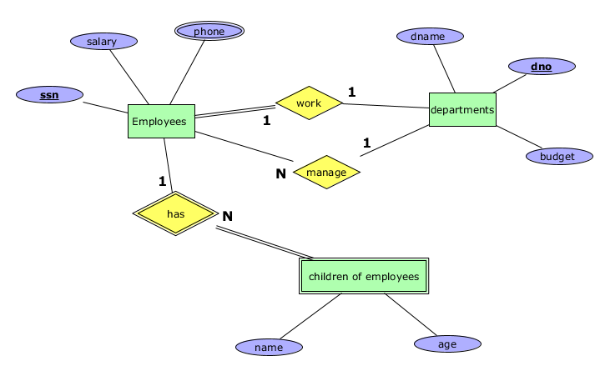

2. Draw an ER diagram that captures this information.

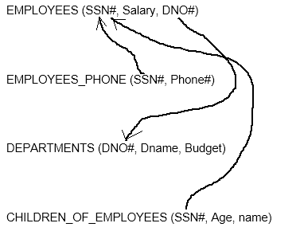

**2. Exercise 2**

Draw a relational schema diagram specifying the foreign keys for this schema.

